ROHM Switching Regulator Solutions

Evaluation Board:

Synchronous Buck Converter

Integrated FET

BD9E151NUX-E2EVK-101 (5.0V | 1.2A Output)

No.000000000

* Introduction

This application note will provide the steps necessary to operate and evaluate ROHM’s synchronous buck DC/DC converter using the BD9E151NUX evaluation boards. Component selection, board layout recommendations, operation procedures and application data is provided.

* Description

This evaluation board has been developed for ROHM’s synchronousbuck DC/DC converter customers evaluating BD9E151NUX. While accepting a power supply of 6.0-28.0V, an output of 1.0V to 23.0V can be produced. The IC has internal 80mOhm high-side MOSFET and a operation frequency fixed to 600 kHz. A fixed Soft Start circuit prevents in-rush current during startup along with UVLO (low voltage error prevention circuit) and TSD (thermal shutdown detection) protection circuits. An EN pin allows for simple ON/OFF control of the IC to reduce standby current consumption.

* Applications

Surveillance Camera Applications

OA Applications

12V, 24V Distributed Power Systems

* Evaluation Board Operating Limits and Absolute Maximum Ratings

|  |  |  |  |  |  |  |  |
| --- | --- | --- | --- | --- | --- | --- | --- |
| **Parameter** | | **Symbol** | **Limit** | | | **Unit** | **Conditions** |
| **MIN** | **TYP** | **MAX** |
| **Supply Voltage** | | | | | | | |
|  | BD9E151NUX | V­CC | 6.0 | - | 28.0 | V |  |
| **Output Voltage / Current** | | | | | | | |
|  | BD9E151NUX | VOUT | 1.0(*2) | - | VINx0.7  or  VIN-5 | V | * Set by R1 and R2 |
| IOUT | - | - | 1.2 | A |  |

(*2)Restricted by minimum on pulse typ. 100nsec

* Evaluation Board

Below is evaluation board with the BD9E151NUX.

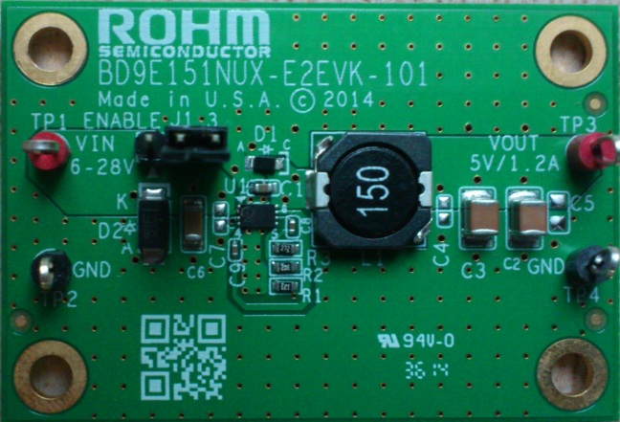

Fig 1: BD9E151NUX Evaluation Board

**Vout**

**GND**

**EN**

BD9673EFJ Eval Board

* Evaluation Board Schematic

Below is evaluation board schematic for BD9E151NUX.

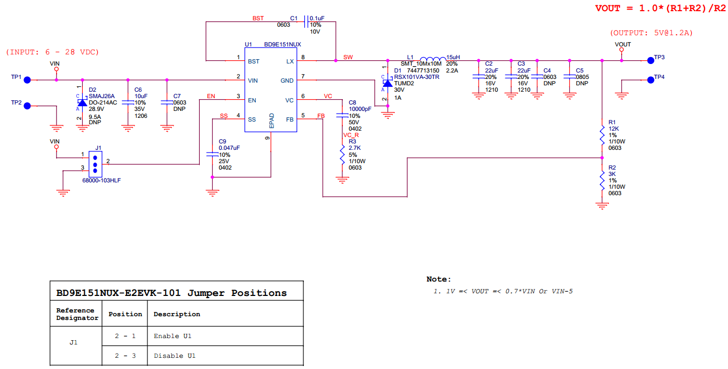

Fig 2: BD9E151NUX Evaluation Board Schematic

* Evaluation Board I/O

Below is reference application circuit that shows the inputs (VIN, EN) and the output (VOUT).

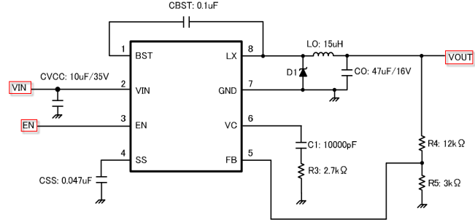

Fig 3: BD9E151NUX Evaluation Board I/O

* Evaluation Board Operation Procedures

Below is the procedure to operate the evaluation board.

1. Connect power supply’s GND terminal to GND test point TP2 on the evaluation board.
2. Connect power supply’s VCC terminal to VIN test point TP1 on the evaluation board. This will provide VIN to the IC U1. Please note that the VCC should be in range of 6V to 28V.
3. Check if shunt jumper of J1 is at position ON (Pin2 connect to Pin1, EN pin of IC U1 is pulled high).
4. Connect electronic load to TP3 and TP4. Do not turn on load.
5. Turn on power supply. The output voltage VOUT (+5V) can be measured at the test point TP3. Now turn on the load. The load can be increased up to 1.2A MAX.

*Notes*:

*The board does not support hot plugging protection. Please do not hot plug power supply.*

* Reference Application Data for BD9E151NUX-E2EVK-101

Following graphs show quiescent current, efficiency, load response, output voltage ripple response of the BD9E151NUX evaluation board.

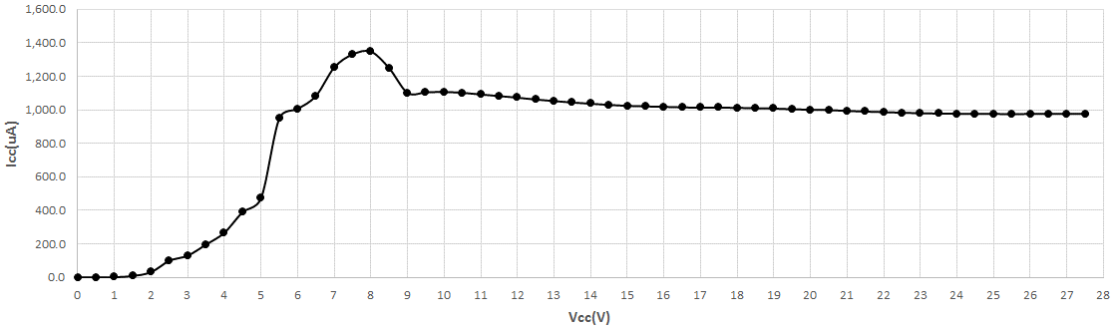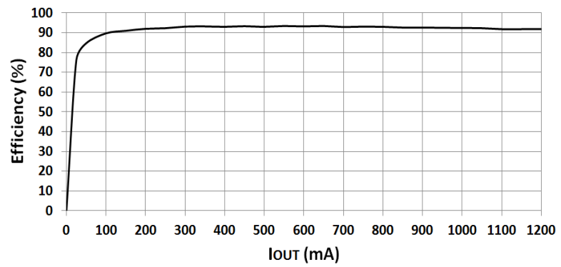

**Fig 4: Circuit Current vs. Power supply Voltage Characteristics (VIN = 0-28V, Temp=25oC)**

**Fig 5: Electric Power Conversion Rate**

**(Vin=12V, VOUT=5V)**

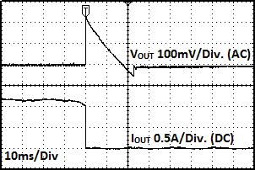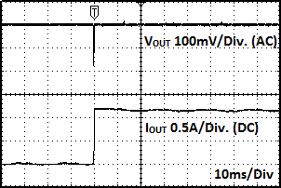

Fig 6: Load Response Characteristics

(VIN=12V, VOUT=5V, IOUT=0A 🡪 1.2A)

Fig 7: Load Response Characteristics

(VIN =12V, VOUT =5V, IOUT =1.2A 🡪 0A)

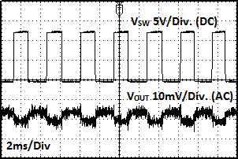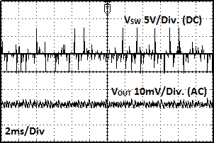

Fig 8: Output Voltage Ripple Response Characteristics

(VIN=12V, VOUT=5V, IOUT=0A)

Fig 9: Output Voltage Ripple Response Characteristics

(VIN=12V, VOUT=5V, IOUT=1.2A)

* Evaluation Board Layout Guidelines

Below are the guidelines that have been followed and recommended for BD9E151NUX designs.

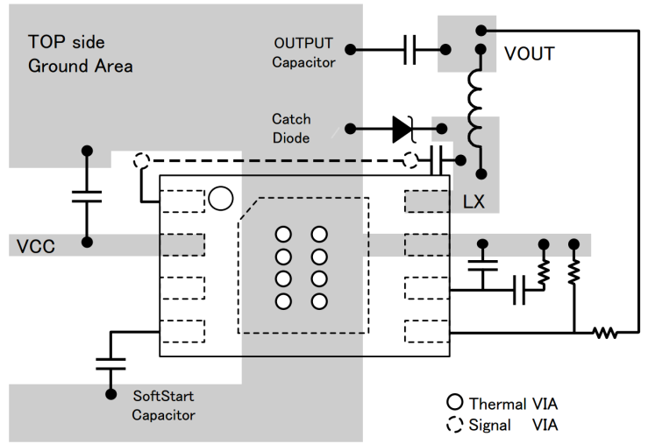

Fig 10: BD9E151NUX PCB Layout

Layout is a critical portion of good power supply design. There are several signals paths that conduct fast changing currents

or voltages that can interact with stray inductance or parasitic capacitance to generate noise or degrade the power supplies

performance. To help eliminate these problems, the VIN pin should be bypassed to ground with a low ESR ceramic bypass

capacitor with B dielectric. Care should be taken to minimize the loop area formed by the bypass capacitor connections, the

VIN pin, and the anode of the catch diode. See Fig 10 for a PCB layout example.

In the BD9E151NUX, since the LX connection is the switching node, the catch diode and output inductor should be located

close to the LX pins, and the area of the PCB conductor minimized to prevent excessive capacitive coupling. And GND area

should not be connected directly power GND, connected avoiding the high current switch paths. The additional external

components can be placed approximately as shown.

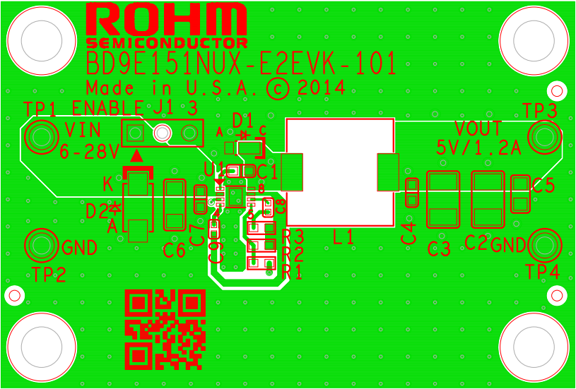

Fig 11: BD9E151NUX-E2EVK-101 Board PCB layout

* Calculation of Application Circuit Components

(1) Inductors

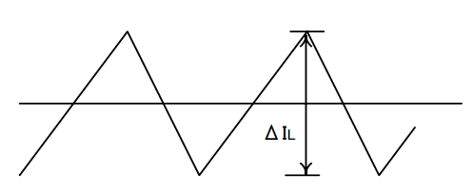

Fig 12: Inductor Current

Something of the shield type that fulfills the current rating (Current value

Ipecac below), with low DCR is recommended. Value of Inductance influences

Inductor Ripple Current and becomes the cause of Output Ripple.

In the same way as the formula below, this Ripple Current can be made small for as big as the L value of Coil or as high as the Switching Frequency.

(⊿IL: Output Ripple Current, VIN: Input Voltage, VOUT: Output Voltage, f: Switching Frequency)

For design value of Inductor Ripple Current, please carry out design tentatively with about 20%～50% of Maximum Input

Current

(2) Output Capacitor

In order for capacitor to be used in output to reduce output ripple, Low ceramic capacitor of ESR is recommended.

Also, for capacitor rating, on top of putting into consideration DC Bias characteristics, please use something whose

maximum rating has sufficient margin with respect to the Output Voltage. Output ripple voltage is looked for using the

following formula. The actual value of the output capacitor is not critical, but some practical limits do exist. Consider the

relationship between the crossover frequency of the design and LC corner frequency of the output filter. In general, it is

desirable to keep the crossover frequency at less than 1/5 of the switching frequency. With high switching frequencies

such as the 600kHz frequency of this design, internal circuit limitations of the BD9E151NUX limit the practical maximum

crossover frequency to about 30kHz. In general, the crossover frequency should be higher than the corner frequency

determined by the load impedance and the output capacitor. This limits the minimum capacitor value for the output filter

to:

Where: Rl is the output load resistance and fc_max is the maximum crossover frequency. The output ripple voltage can

be estimated by:

Please design in a way that it is held within Capacity Ripple Voltage.

In the BD9E151NUX, it is recommended a ceramic capacitor more than 10µF.

(3) Output Voltage Setting

ERROR AMP internal Standard Voltage is 1.0V. Output Voltage is determined as seen in (5) formula

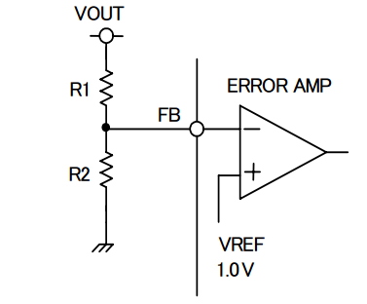

Fig 13: Output Voltage Setting

(4) Bootstrap Capacitor

Please connect from 0.047µF to 0.47µF (Laminate Ceramic Capacitor) between BST Pin and LX Pin.

(5) Soft Start Function

It is highly recommended to program the soft start time externally to prevent high inrush current because no soft start time is implemented internally. A capacitor (Css) connected between the SS pin and ground implements a soft start time.The BD9E151NUX has an internal pull-up current source of 2uA that charges the external soft start capacitor. The equation for the soft start time (10% to 90%) is shown in below Equation.

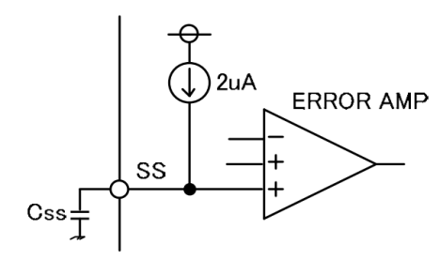

Fig 14: Soft Start Time Setting

The Iss current is 2uA.

(6) Catch Diode

The BD9E151NUX is designed to operate using an external catch diode between LX and GND. The selected diode

must meet the absolute maximum ratings for the application: Reverse voltage must be higher than the maximum voltage

at the LX pin, which is VINMAX + 0.5 V. Peak current must be greater than IOUTMAX+⊿IL plus on half the peak to

peak inductor current. Forward voltage drop should be small for higher efficiencies. It is important to note that the catch

diode conduction time is typically longer than the high-side FET on time, so attention paid to diode parameters can

make a marked improvement in overall efficiency. Additionally, check that the device chosen is capable of dissipating

the power losses.

(7) Input Capacitor

The BD9E151NUX requires an input capacitor and depending on the application. Use low ESR capacitors for the best

performance. Ceramic capacitors are preferred, but low-ESR electrolytic capacitors may also suffice. The typical

recommended value for the decoupling capacitor is 10uF. Please place this capacitor as possible as close to the VIN pin.

When using ceramic capacitors, make sure that they have enough capacitance to provide sufficient charge to prevent

excessive voltage ripple at input. The input voltage ripple caused by capacitance can be estimated by:

Since the input capacitor (CVIN) absorbs the input switching current it requires an adequate ripple current rating. The

RMS current in the input capacitor can be estimated by:

The worst case condition occurs at VIN= 2VOUT, where

(8) About Adjustment of DC/DC Comparator Frequency Characteristics

Role of Phase compensation element C1, C2, R3 (See Fig 3 Example of Reference Application Circuit)

Stability and Responsiveness of Loop are controlled through VC Pin which is the output of Error Amp.

The combination of zero and pole that determines Stability and Responsiveness is adjusted by the combination of

resistor and capacitor that are connected in series to the VC Pin.

DC Gain of Voltage Return Loop can be calculated for using the following formula.

Here, VFB is Feedback Voltage (1.0V).AEA is Voltage Gain of Error amplifier (typ : 60 dB),

Gcs is the Trans-conductance of Current Detect (typ : 10A/V),and Rl is the Output Load Resistance value.

There are 2 important poles in the Control Loop of this DC/DC.

The first occurs with through the output resistance of Phase compensation Capacitor (C1)and Error amplifier.

The other one occurs with through the Output Capacitor and Load Resistor.

These poles appear in the frequency written below.

Here, GEA is the trans-conductance of Error amplifier (typ : 250uA/V).

Here, in this Control Loop, one zero becomes important.

With the zero which occurs because of Phase compensation Capacitor C1 and Phase compensation Resistor R3, the

Frequency below appears.

Also, if Output Capacitor is big, and that ESR (RESR) is big, in this Control Loop, there are cases when it has an

important, separate zero (ESR zero).

This ESR zero occurs due to ESR of Output Capacitor and Capacitance, and exists in the Frequency below.

(ESR zero)

In this case, the 3Rd pole determined with the 2nd Phase compensation Capacitor (C2) and Phase Correction Resistor

(R3) is used in order to correct the ESR zero results in Loop Gain.

This pole exists in the frequency shown below.

(pole that corrects ESR zero)

The target of Phase compensation design is to create a communication function in order to acquire necessary band

and Phase margin.

Cross-over Frequency (band) at which Loop gain of Return Loop becomes “0” is important.

When Cross-over Frequency becomes low, Power supply Fluctuation Response, Load Response, etc worsens.

On the other hand, when Cross-over Frequency is too high, instability of the Loop can occur.

Tentatively, Cross-over Frequency is targeted to be made 1/20 or below of Switching Frequency. Selection method of

Phase Compensation constant is shown below.

1. Phase Compensation Resistor (R3) is selected in order to set to the desired Cross-over Frequency.

Calculation of RC is done using the formula below.

Here, fc is the desired Cross-over Frequency. It is made about 1/20 and below of the Normal Switching Frequency (fs).

2. Phase compensation Capacitor (C1) is selected in order to achieve the desired phase margin.

In an application that has a representative Inductance value (about several 10uH～22uH), by matching zero of

compensation to 1/4 and below of the Cross-over Frequency, sufficient Phase margin can be acquired. C1 can be

calculated using the following formula.

RC is Phase compensation Resistor.

3. Examination whether the second Phase compensation Capacitor C2 is necessary or not is done.

If the ESR zero of Output Capacitor exists in a place that is smaller than half of the Switching Frequency, a second

Phase compensation Capacitor is necessary. In other words, it is the case wherein the formula below happens.

In this case, add the second Phase compensation Capacitor C2, and match the frequency of the third pole to the

Frequency fp3 of ESR zero.

C2 is looked for using the following formula.

Output Voltage Restriction

BD9E151NUX have a function of BSTUVLO to prevent malfunction at low voltage between BST and LX. Therefore

OUTPUT voltage is restricted by BSTUVLO and Max Duty Cycle (min 85%).

① Restriction by BST-UVLO

When the voltage between BST and Lx is lower than 2.5V, High-Side FET will be made turned off and the charge will

provide from VIN to BST directly to reset BSTUVLO (path①). The below formula is needed to be satisfied to reset

BSTUVLO.

Here, BSTUVLO reset: BSTUVLO reset voltage, VF: the diode forward bias voltage between VIN and BST

Considering the fluctuation of BSTUVLO reset voltage and VF, maximum voltage is more than 5V.

Therefore maximum output voltage is defined as VIN - 5V.

②Restriction by Max Duty Cycle

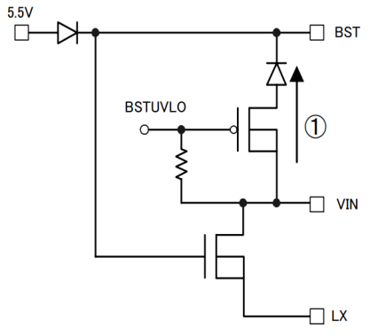

Fig 15: BST charge pass

Maximum output voltage is restricted by Max Duty Cycle (min 85%).

In this time it is needed to consider the effect of NchFET Ron

, OUTPUT current and forward voltage of SBD. OUTPUT voltage

can be calculated using the following formula.

Considering the effect of catch diode type and the loss by inductor,

Vomax = (VIN-Ron×Iomax)×0.85 (casually formula)

Considering the negative voltage in the case of pulling diode current,

maximum voltage is more than VIN×0.7.

Therefore maximum output voltage is defined as VIN×0.7.

Considering above restriction, adopt the lower output voltage as maximum voltage

* Evaluation Board BOM

Below is a table with the build of materials. Part numbers and supplier references are provided.

|  |  |  |  |  |  |
| --- | --- | --- | --- | --- | --- |
| **Item** | **Qty.** | **Ref** | **Description** | **Manufacturer** | **Part Number** |
| 1 | 1 | C1 | CAP CER 0.1UF 16V 10% X7R 0603 | Murata | GRM188R71C104KA01D |
| 2 | 2 | C2,C3 | CAP CER 22UF 16V 20% X7R 1210 | Murata | GRM32ER71C226MEA8 |
| 3 | 1 | C6 | CAP CER 10UF 35V 10% X5R 1206 | Murata | GRM31CR6YA106KA12L |
| 4 | 1 | C8 | CAP CER 10000PF 50V 10% X7R 0402 | Murata | GRM155R71H103KA88D |
| 5 | 1 | C9 | CAP CER 0.047UF 25V 10% X7R 0402 | Murata | GRM155R71E473KA88D |
| 6 | 1 | D1 | DIODE SCHOTTKY 30V 1A 2TUMD | ROHM | RSX101VA-30TR |
| 7 | 1 | J1 | CONN HEADER VERT .100 3POS 15AU | FCI | 68000-103HLF |
| 8 | 1 | L1 | INDUCTOR POWER 15UH 2.2A SMD | Wurth Electronics | 7447713150 |
| 9 | 1 | R1 | RES 12K OHM 1/10W 1% 0603 SMD | ROHM | MCR03ERTF1202 |
| 10 | 1 | R2 | RES 3K OHM 1/10W 1% 0603 SMD | ROHM | MCR03ERTF3001 |
| 11 | 1 | R3 | RES 2.7K OHM 1/10W 1% 0603 SMD | ROHM | MCR03ERTF2701 |
| 12 | 2 | TP1,TP3 | TEST POINT PC MULTI PURPOSE RED | Keystone Electronics | 5010 |
| 13 | 2 | TP2,TP4 | TEST POINT PC MULTI PURPOSE BLK | Keystone Electronics | 5011 |
| 14 | 1 | U1 | IC REG BUCK ADJ 1.2A 8VSON | ROHM | BD9E151NUX-TR |
| 15 | 1 |  | Shunt jumper for header J1 (item #8), CONN SHUNT 2POS GOLD W/HANDLE | TE Connectivity | 881545-1 |

**Notes**

No copying or reproduction of this document, in part or in whole, is permitted without the consent of ROHM Co.,Ltd.

The content specified herein is subject to change for improvement without notice.

The content specified herein is for the purpose of introducing ROHM's products (hereinafter "Products"). If you wish to use any such Product, please be sure to refer to the specifications, which can be obtained from ROHM upon request.

Examples of application circuits, circuit constants and any other information contained herein illustrate the standard usage and operations of the Products. The peripheral conditions must be taken into account when designing circuits for mass production.

Great care was taken in ensuring the accuracy of the information specified in this document. However, should you incur any damage arising from any inaccuracy or misprint of such information, ROHM shall bear no responsibility for such damage.

The technical information specified herein is intended only to show the typical functions of and examples of application circuits for the Products. ROHM does not grant you, explicitly or implicitly, any license to use or exercise intellectual property or other rights held by ROHM and other parties. ROHM shall bear no responsibility whatsoever for any dispute arising from the use of such technical information.

The Products specified in this document are intended to be used with general-use electronic equipment or devices (such as audio visual equipment, office-automation equipment, communication devices, electronic appliances and amusement devices).

The Products specified in this document are not designed to be radiation tolerant.

While ROHM always makes efforts to enhance the quality and reliability of its Products, a Product may fail or malfunction for a variety of reasons.

Please be sure to implement in your equipment using the Products safety measures to guard against the possibility of physical injury, fire or any other damage caused in the event of the failure of any Product, such as derating, redundancy, fire control and fail-safe designs. ROHM shall bear no responsibility whatsoever for your use of any Product outside of the prescribed scope or not in accordance with the instruction manual.

The Products are not designed or manufactured to be used with any equipment, device or system which requires an extremely high level of reliability the failure or malfunction of which may result in a direct threat to human life or create a risk of human injury (such as a medical instrument, transportation equipment, aerospace machinery, nuclear-reactor controller, fuel-controller or other safety device). ROHM shall bear no responsibility in any way for use of any of the Products for the above special purposes. If a Product is intended to be used for any such special purpose, please contact a ROHM sales representative before purchasing.

If you intend to export or ship overseas any Product or technology specified herein that may be controlled under the Foreign Exchange and the Foreign Trade Law, you will be required to obtain a license or permit under the Law.



Thank you for your accessing to ROHM product information.

More detail product information and catalogs are available, please contact us.

**ROHM Customer Support System**

<http://www.rohm.com/contact/>